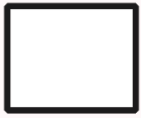
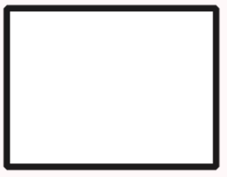
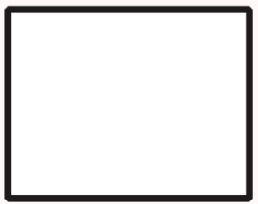
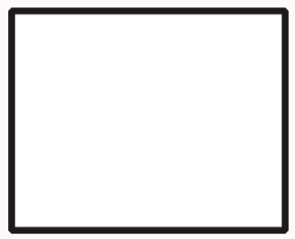
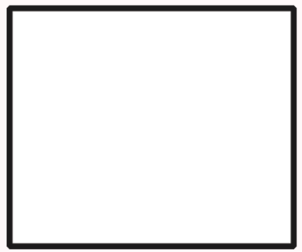
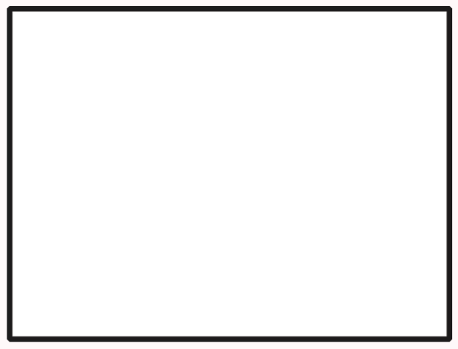
40in x 30in
(101.6cm x 76.20cm)
18in x 14in
(45.72cm x 35.56cm)
20in x 16in
(50.8cm x 40.64cm)
24in x 20in
(60.96cm x 50.8cm)
16in x 12in
(40.64cm x 30.48cm)
(25.4cm x 20.32cm)
10in x 8in

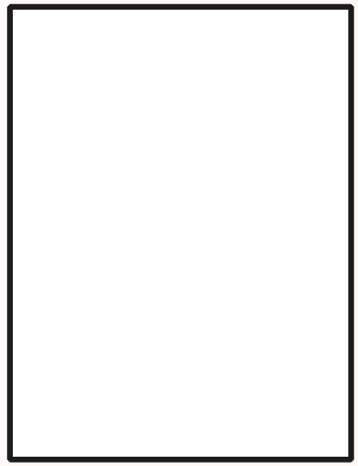

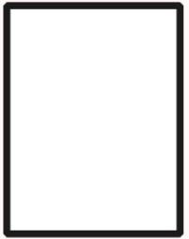
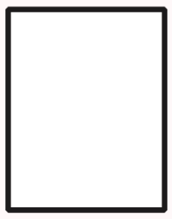
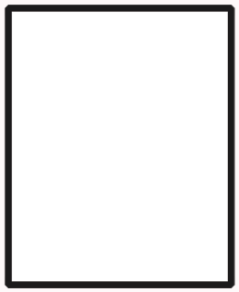
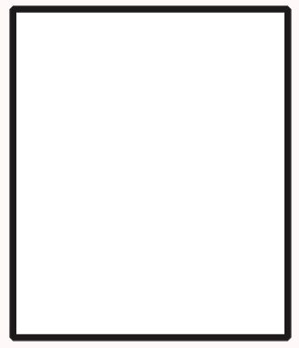
30in x 40in
(76.20cm x 101.6cm)
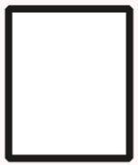

(20.32cm x 25.4cm)
14in x 18in
(35.56cm x 45.72cm)
8in x 10in
12in x 16in
16in x 20in
(40.64cm x 50.8cm)
20in x 24in
(50.8cm x 60.96cm)
(30.48cm x 40.64cm)

