General Instructions
Upon downloading the file after your purchase:
- Print it out in A4 or US Letter sizes with a paper type of your choice, either of the following:
  - Glossy Photo Paper
  - Matte Photo Paper

Instructions (A4 Size) – 8.25 in x 11.75 in
- Cut across the dotted line in the middle, horizontally with a pair of scissors
- Fold downwards from the ‘BACK’ as depicted in the attached photos
- And.. That’s it!! Enjoy!

Instructions (US Letter Size) – 8.5 in x 11 in
- Snip off the boundaries
- Fold downwards from the ‘BACK’ as depicted in the attached photos
- And.. That’s it!! Enjoy!

Pointers to Note:
- This product is fully a digital download, which will be available to do so upon payment
- All illustrations and artwork are in high quality of at least 300 DPI (Dots Per Inch)

Recommendations:
- Use a cutter for a clean fine cut to prevent jaggedness or unequal cuts
- Use a thicker paper or card stock to achieve a bulkier printed product
- Use papers which are of at least 160g/m² or 5.6 oz/sq. feet and above

To Avoid:
- Try to not use light weighted or reduced thickness print paper

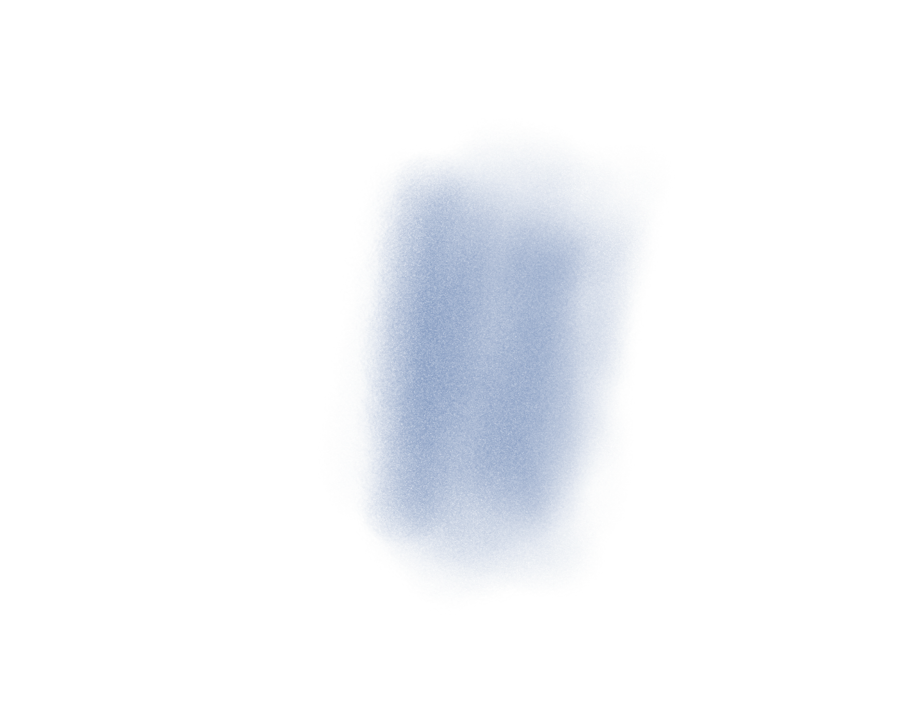

FRONT
BACK

7” (17.78cm)
FOLD HERE

5” (12.7cm)
CUT HERE

